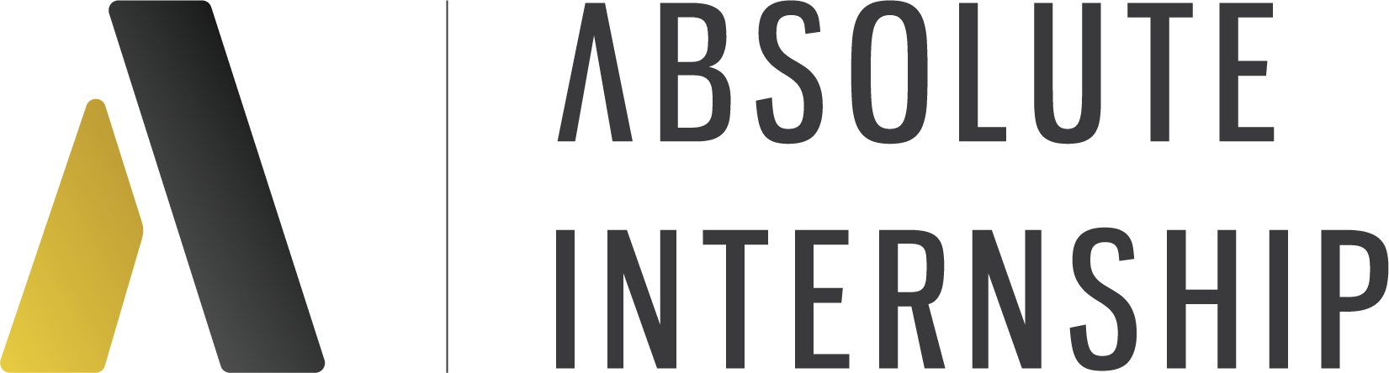
Program Timeline:
February 13, 2024 - UC Berkeley session on internships 4pm- 5:30pm PST. Students are given the meeting link to book their virtual advising calls.
February 14, 2024 - February 21, 2024: virtual advising call with Absolute Internship to determine program location and internship industry.
February 23, 2024 - all updated resumes, copy of passports, profile pictures and health forms should be submitted to Absolute Internship.
February 26, 2024 - students can begin to schedule their preparation calls. Please refer to the detailed placement process below.
March 4, 2024 - April 26, 2024: Interviews with host companies and organizations take place.
May 3, 2024: All internships should be confirmed for the May 31, 2024 start date

Placement Process - average time is 2 to 6 weeks

1 | Preparation Call ✅
Already done, you're one step closer to the start of your internship program!

2 | Update your CV or Industry of Choice 💻
You might have been asked to update your industry of choice if or to send an updated version of your CV. Here are some resources to help you write and update your resume: Wonsulting on YouTube and Erin McGoff on TikTok.

3 | Searching for internship opportunities 🕵️
We will work hard on finding internship opportunities in your industry of choice, and your profile will be sent to different companies that match your profile. You will not be able to choose between different companies.

4 | Interview with an interested company 👩‍💻
Once a company is interested in your profile we will arrange an interview. Whether you are accepted by a company is based on your performance in the interview, here is a link to a podcast with some interview tips: Interview Boss.

5 | Internship confirmed 🎉
If after your first interview, the interviewer decides to accept you, you will automatically be placed with the first company. Once the company confirms they will move forward, your Program Manager will reach out with documents you'll need to sign as well as a Job Description with details about your internship.

If the company decides not to move forward we will arrange another interview with a second company, but don't worry 8/10 interns get placed after their first interview!

5 | Ready, set go! ✈️
Congratulations! All documents are signed and your internship is confirmed. Time to finish preparing for your international professional development experience, and head off to your destination. Make sure you have sent in all necessary documents and filled out all the forms .

